

**EE 463**

***HARDWARE PROJECT***

**AC to DC MOTOR DRIVE**

**Mehmet Eralp KÖSE 2031094**

**Mahmut Enes KARA 2030898**

**Course Instructor: Ozan KEYSAN**

**Course Assistant: İlker ŞAHİN**

# Introduction

In this report, detailed information about Hardware Project of METU EE 463 Course which is mainly driving a DC motor which can be seen on Figure 1, from AC power supply is presented. Main phenomena behind the project is that implementing a controllable rectifier which takes input as 3 phase AC or 1 phase AC and converting it to controllable DC. Then this controllable DC is required to drive DC motor as a load by adjusting its speed.

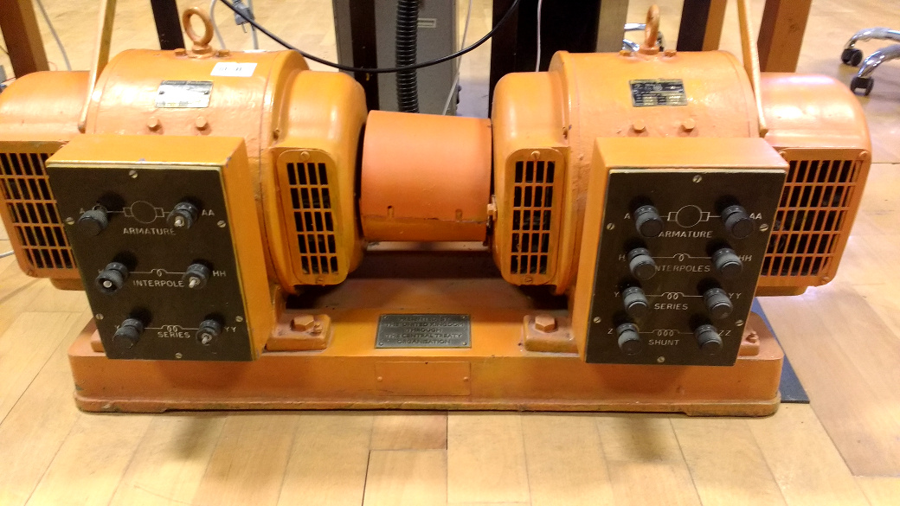Figure 1: DC Motor setup coupled with generator

Project is implemented step by step in order to achieve a successful operation of the driver. Firstly, comparison between rectifiers which are 3 phase thyristor, 1 phase thyristor and 3 phase diode + Buck converter rectifiers are discussed in terms of difficulties, cost and time consumption. So, best option is selected according to our considerations. Then project is simulated in digital environment and performances of the theoretical results are observed. Required equipment and their essential power, voltage, current etc. ratings are calculated and listed. Values of passive circuit components such as capacitors and inductors are obtained from computer simulations. Finally, setup circuitry is constructed with decided components and some test results are obtained while feeding a R load only. Then setup is connected to DC motor and performance of the setup is tested.

# Comparison of the Topologies

As a first step of the project, most advantageous topology is selected according to ease of implementation, ease of gate drive circuitry for required topology and cost.

1 phase thyristor rectifier has high output voltage ripple and it probably requires large passive elements as a filter compared to 3 phase rectifiers. Also, it consists of 2 pair of thyristor while 3 phase rectifier consists of 3 pair of thyristor. So, this topology can be upgraded by just one pair of thyristor, in other words performance of the 3 phase rectifier is much better than 1 phase thyristor rectifier in terms of cost. Therefore this topology was not selected.

3 phase thyristor rectifier can be considered as simple in terms of required circuit components. It just requires a 3 pair thyristor module as a main circuitry. But the important thing about 3 phase thyristor rectifier is complexity of the gate driver circuitry. This circuitry is supposed to be create 6 specific synchronized pulse in one period in order to trigger thyristor gate pins separately. As this phenomena requires many synchronization transformer and complex control circuitry, its cost is very high and implementation of it very difficult and time consuming. Therefore this topology was not selected.

3 phase diode rectifier is accessible in the market compared to other topologies and its operation is very basic. But the project requires controllable DC output and this requirement can not achieved by just a rectifier module. A buck converter should be used in order to make output voltage controllable. A buck converter should be contain at least a switching element such as Mosfet and IGBT, and a freewheeling diode. Gate driver circuitry is required for gate of the switching element but it can be considered as very simple compared to thyristor gate driver circuitries as it does not require any synchronization transformer and complex control circuitry. A simple PWM producer with a potentiometer can be used with amplification circuitry of the gate driver. Therefore, the topology for the project is selected as 3 phase diode rectifier and a cascaded buck converter. In order to produce a PWM signal with variable duty cycle, an Arduino microcontroller is going to be used with a potentiometer. In order to isolate Ardunio from main circuitry and provide required current for gate of the switching element, an optocoupler which name is TLP 250 is going to be used.

# Theory of Operation

## Theory of Main Circuitry

Overall circuit diagram can be constructed as Figure 2 for selected topology, diode rectifier and buck converter. 3 phase diode rectifier takes input from 3 phase AC source and converts to 6 pulse DC waveform whose mean value is 1.35*Vs where Vs is line to line voltage of the source. In order to make output voltage of the diode rectifier smoother a filter capacitor is going to be used. Therefore, it is expected to obtain ripple free, pure DC voltage. A MOSFET and a freewheeling diode takes DC input from the rectifier and provide variable DC output whose value is D*VD where D is duty cycle applied to gate of the MOSFET and VD is output of the rectifier. A LC filter takes output of the buck converter and smooths current and voltage of the load. Note that DC motor can be considered as a RL load, therefore it also draws approximately DC current without filter but voltage of the DC motor shuttle between zero, MOSFET is off, and high DC value, MOSFET is on, at the switching frequency of the gate driver. So, motor may be influenced from this situation in a long time. Therefore, using a filter capacitor is decided but it also requires a filter inductance because two filter capacitors should not be shorted at any time i.e. when MOSFET is on, current drawn from first capacitor should be limited.

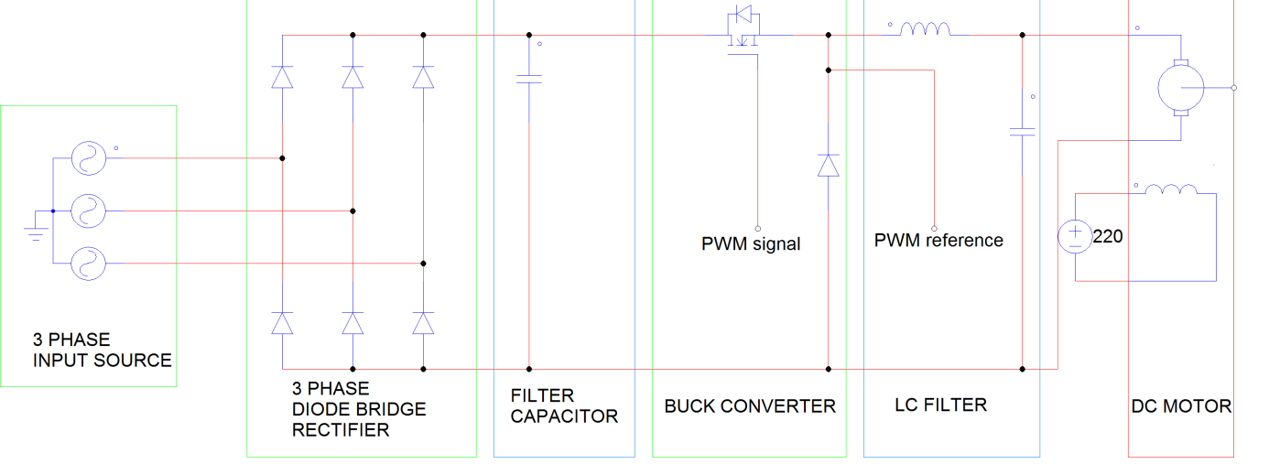Figure 2: Overall circuitry

## Theory of Gate Driver

Ideally MOSFETs don’t require any feeding current for opening from their gate pin. But practically gate to source capacitance of them should be charged while opening the MOSFET and should be uncharged while closing the MOSFET. This problem can be solved easily in small application because charging and discharging this capacitance just requires currents about ten mA range. But in power MOSFET this problem should be tackled by carefully. PWM signal should be amplified before connected to gate of MOSFET. Also isolation of this circuitry should be provided for safe operation.

In order to provide both isolation and amplification, gate driver modules are investigated and it is pointed out that TLP 250 [1] can supply both isolation and amplification of the signal. As seen from Figure 3, TLP 250 is an optocoupler module which turns on the inside led according to its input. By the help of the photosensor on the other side of the module lighting of led is captured. So isolation is provided. In order to drive led of the module Arduino’s PWM output is sufficient because it requires 11 mA and Arduino’s PWM output can supply up to 30 mA.

In order to provide amplification, TLP 250 has amplifier circuitry after photosensor as seen from Figure 3. Therefore output of the module can be connected to MOSFET gate with a small resistance value in order to prevent instantaneous high current drawing. On the other hand VCC and GND of the module which are 8th and 5th pins respectively should be supplied from a floating DC source because it GND pin should be connected to MOSFET source pin. TLP 250 requires at least 15 V for its DC supply pins. Therefore two 9 V cell batteries may be connected as DC supply. Also a bypass capacitor which is 0.1µF and a protection resistor, 12 kΩ, is added to circuitry.

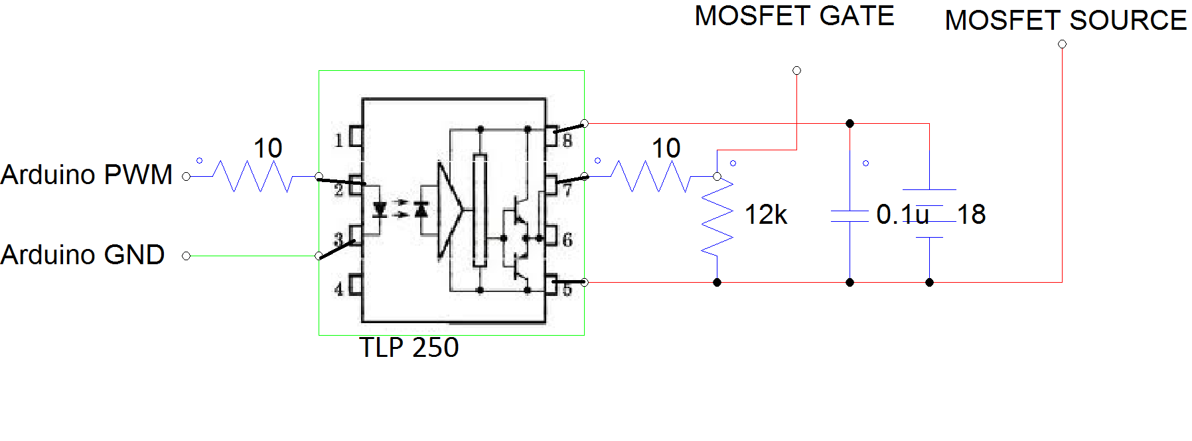Figure 3: Gate Driver Circuitry

References

[1] https://toshiba.semicon-storage.com/info/docget.jsp?did=16821&prodName=TLP250